**grep command:**

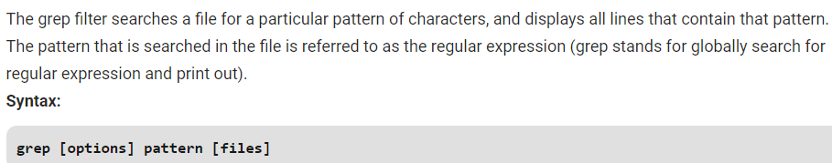

**Options:**

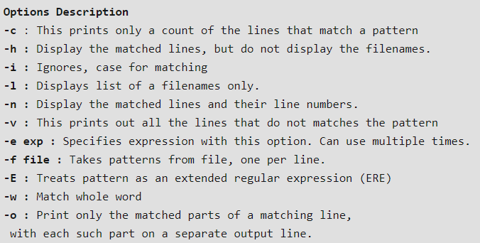

**Examples:**

**Case insensitive search:** The **-i** option enables to search for a string case insensitively in the give file. It matches the words like “UNIX”, “Unix”, “unix”.

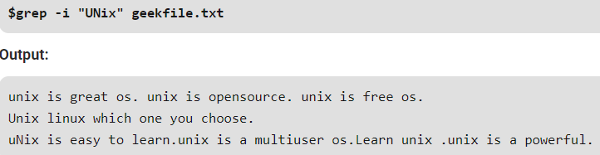

We can also use the below command to search the string in all files. It also displays the string along with the file name as below.

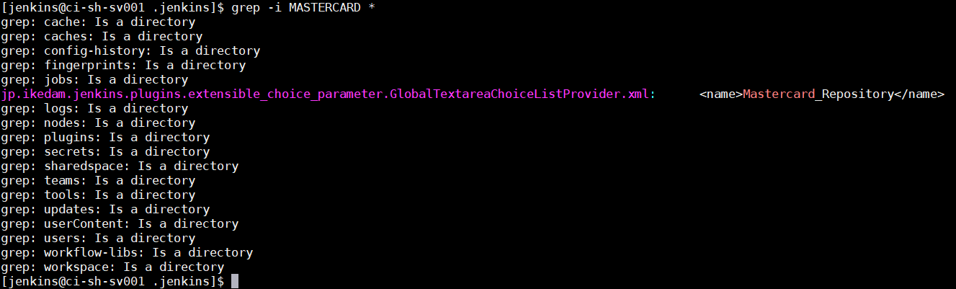

**Displaying the count of number of matches:** We can find the number of lines that matches the given string/pattern

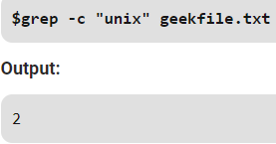

**Display the file names that matches the pattern:** We can just display the files that contains the given string/pattern but not the string

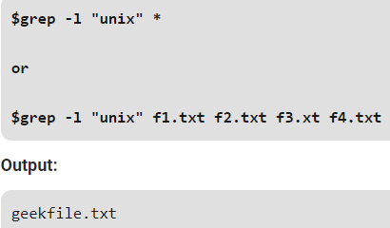

**Checking for the whole words in a file:** By default, grep matches the given string/pattern even if it found as a substring in a file. The -w option to grep makes it match only the whole words.

This will also displays the file name along with string. Just like the with the option “-I”

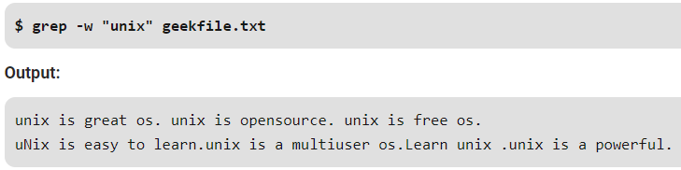

**Displaying only the matched pattern:** By default, grep displays the entire line which has the matched string. We can make the grep to display only the matched string by using the **-o** option.

* **grep -o "unix" geekfile.txt**

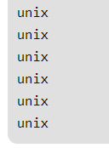

**Show line number while displaying the output using grep -n:** To show the line number of files with the line matched.

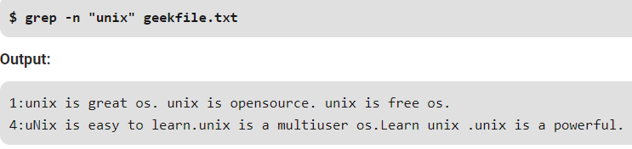

**Inverting the pattern match:** You can display the lines that are not matched with the specified search sting pattern using the -v option.

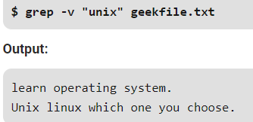

**Matching the lines that start with a string:** The **^** regular expression pattern specifies the start of a line. This can be used in grep to match the lines which start with the given string or pattern.

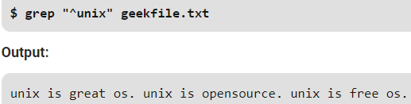

**Matching the lines that end with a string:** The **$** regular expression pattern specifies the end of a line. This can be used in grep to match the lines which end with the given string or pattern.

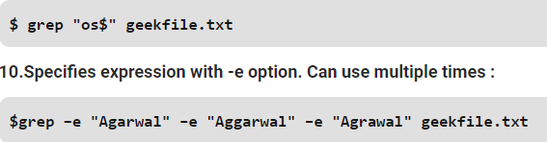

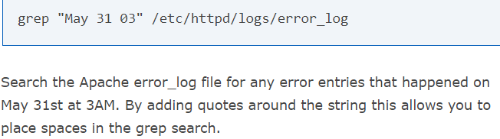

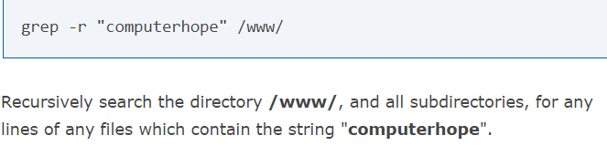

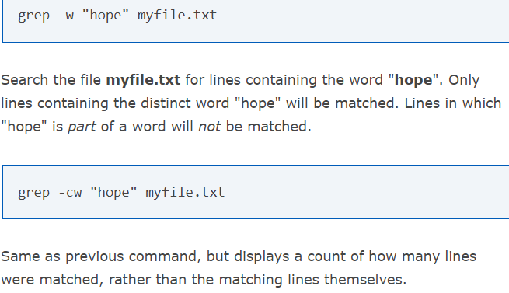

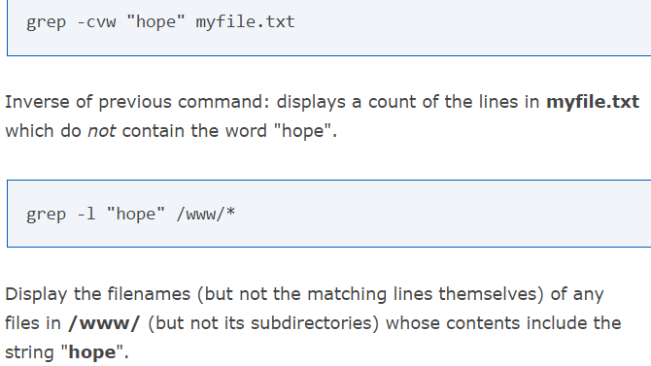

**Some more examples:**

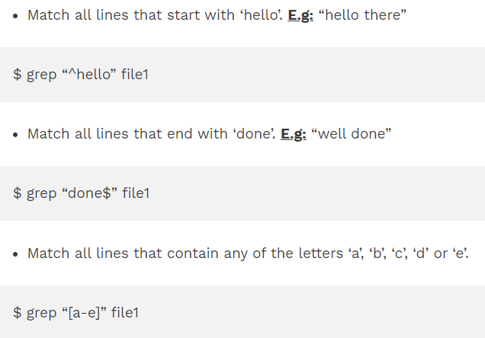

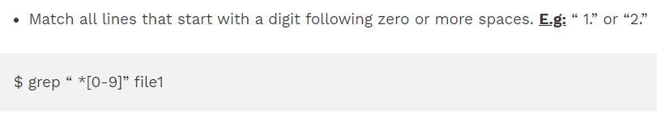

Searching multiple values as below.

